1. sendmsg
According to the PF_INET socket
sendmsg(); /*udp socket*/
||
^
inet_dgram_ops-> sendmsg();/*inet_sendmsg*/
||
^
udp_prot->sendmsg(); /*udp_sendmsg*/

2. udp_sendmsg
a) No MSG_MORE: send packet with one sendmsg
{
skb = ip_make_skb();
{
__ip_append_data();
__ip_make_skb(); /*make frag_list for fragment that can be easy used for the ip_fragment and append the iphdr*/
}
udp_send_skb(skb, fl4); /*add the udp header for the first packet if there are fragmentations*/
}

b) MSG_MORE send packet with multiple sendmsgs, the last should without MSG_MORE that it can send the packet really.

sendmsg1: ip_append_data() make skb append on queue &sk->sk_write_queue
sendmsg2: ip_append_data() get skb from queue &sk->sk_write_queue and make new also append on it
sendmsg3(real send without MSG_MORE)
{
1. get skb from queue &sk->sk_write_queue and make new also append on it
ip_ append _skb();

2. send the packet
udp_push_pending_frames
{
__ip_make_skb();
udp_send_skb();
}
}

3. key function
1). __ip_append_data(): make a sendmsg or multiple sendmsg(MSG_MORE except the last sendmsg) to a single or queue(more than MTU) of skb, it will help L3 to make the packet a list if it is longer than MTU.

a) Fragmentation without Scatter/Gather I/O, no MSG_MORE
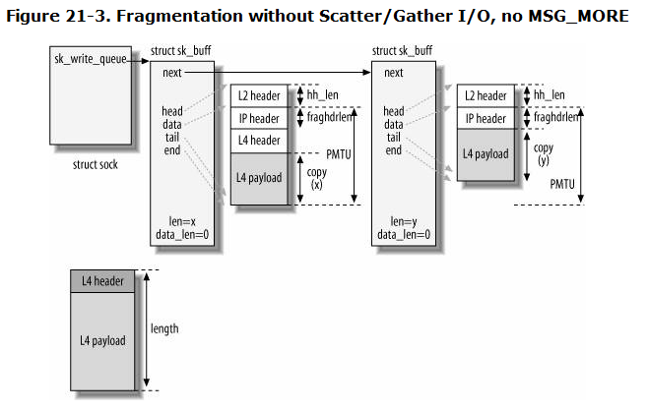

b) Fragmentation without Scatter/Gather I/O, MSG_MORE

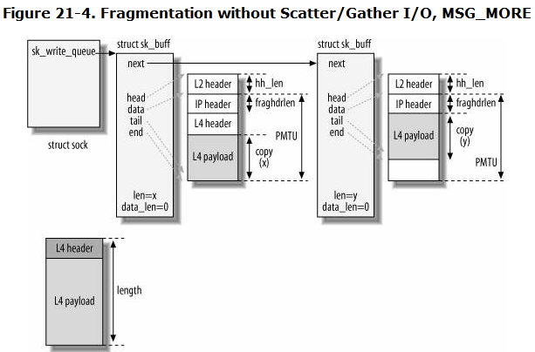

c) ip_append_data with Scatter/Gather I/O and no fragment, I think only when MSG_MORE situation can use it. (a) first sendmsg (b) second sendmsg

skb->data_len = S1; //data length in the pages

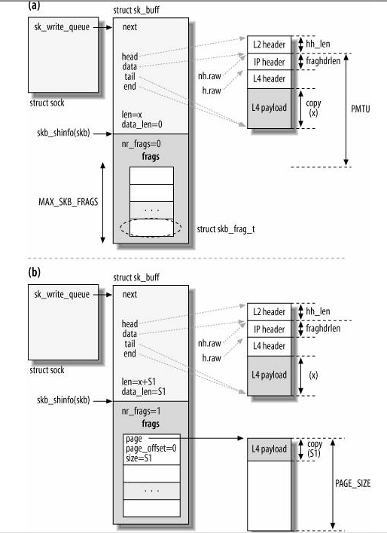

d) Multiple fragments with Scatter/Gather I/O. I think only when MSG_MORE situation can use it.
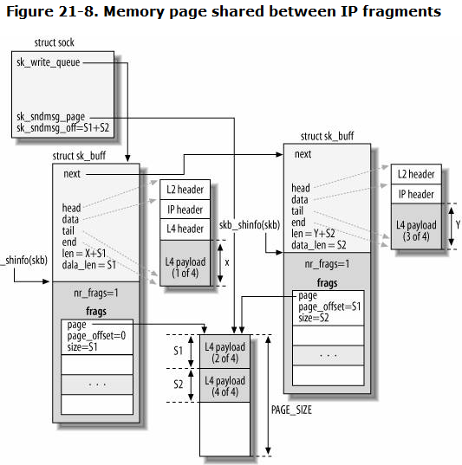

2). __ ip_make_skb()
{
1. make a skb list form the skb queue , so the first skb->len should add all other’s skb->len in the queue, data_len too.
if ((skb = __skb_dequeue(queue)) == NULL)
goto out;
tail_skb = &(skb_shinfo(skb)->frag_list);

/* move skb->data to ip header from ext header */
if (skb->data < skb_network_header(skb))
__skb_pull(skb, skb_network_offset(skb));
while ((tmp_skb = __skb_dequeue(queue)) != NULL) {
__skb_pull(tmp_skb, skb_network_header_len(skb));
*tail_skb = tmp_skb;
tail_skb = &(tmp_skb->next);
skb->len += tmp_skb->len;
skb->data_len += tmp_skb->len;
skb->truesize += tmp_skb->truesize;
tmp_skb->destructor = NULL;
tmp_skb->sk = NULL;
}

2. append the ip header
iph = (struct iphdr *)skb->data;
iph->version = 4;
iph->ihl = 5;
…………
}

3). udp_send_skb()
{
- append the udp header data and checksum
uh = udp_hdr(skb);
uh->source = inet->inet_sport;
uh->dest = fl4->fl4_dport;
......
2. send skb to ip L3
ip_send_skb();
}

EXP: MSG_MORE with scatter/gather I/O
Msg1: 1510
Sendmsg(msg1,MSG_MORE); after __ip_append_data
Skb1->len:1500, skb1_headlen:1500, skb1->data_len:0, skb1_nr_frag:0
Skb2->len:58, skb2_headlen:58, skb1->data_len:0, skb2_nr_frag:0
Msg2: 230
Sendmsg(msg2,MSG_MORE); after __ip_append_data
Skb1->len:1500, skb1_headlen:1500, skb1->data_len:0, skb1_nr_frag:0
Skb2->len:288, skb2_headlen:58, skb1->data_len:230, skb2_nr_frag:1, skb1 page size: 230

Msg3: 1300
Sendmsg(msg3,MSG_MORE); after __ip_append_data
Skb1->len:1500, skb1_headlen:1500, skb1->data_len:0, skb1_nr_frag:0
Skb2->len:1500, skb2_headlen:58, skb1->data_len:1442, skb2_nr_frag:1, skb1 page size: 1442
Skb3->len:108, skb1_headlen:108, skb1->data_len:0, skb1_nr_frag:0

after __ip_make_skb: the fragment ksb->data point to L4 for ip_fragment
skb1->len:3068, skb1_headlen:1500, skb1->data_len:1568, nr_frag:0
skb2->len:1480, skb2_headlen:38, skb2->data_len:1442, nr_frag:1, skb2 page size: 1442
skb3->len:88, skb3_headlen:88, skb3->data_len:0, nr_frag:0

after ip_fragment in the L3 IP: all the skb->data point to the L3
skb1->len:1500, skb1_headlen:1500, skb1->data_len:0, nr_frag:0
skb2->len:1500, skb2_headlen:58, skb2->data_len:1442, nr_frag:1
skb3->len:108, skb3_headlen:108, skb3->data_len:0, nr_frag:0

